Write a Python program to calculate the length of a string.

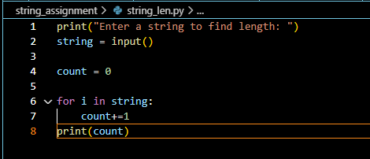



Write a Python program to count the number of characters (character frequency) in a string.

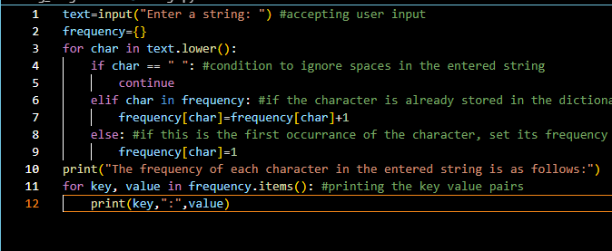

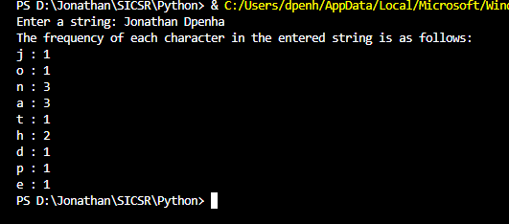

Write a Python program to create a string made of the middle three characters

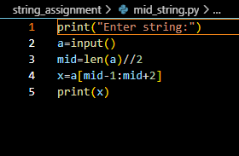

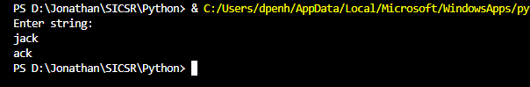

Write a program to accept a string and display it in upper case.

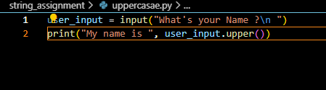

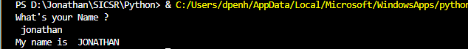

Write a program to accept a string and count the frequency of each vowel (usecount()).

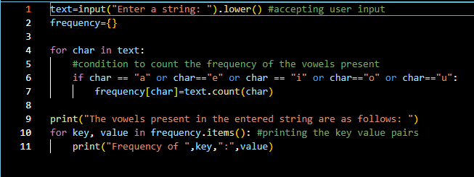

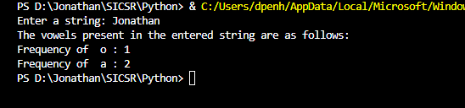

Write a Python program to append new string in the middle of a given string

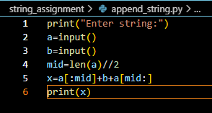

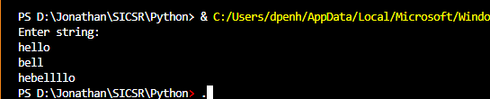

Write a Python program to arrange string characters such that lowercase letters should come first (use lower()

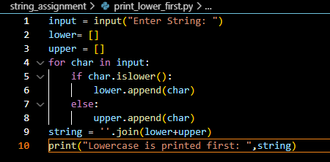



Write a Python program to count all letters, digits, and special symbols from a given string (use isalpha(),isdigit())

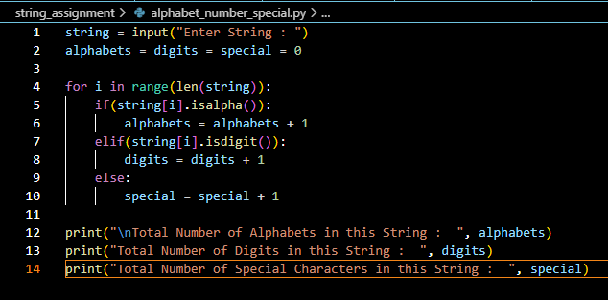

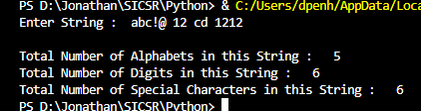

Write a Python program to find all occurrences of a substring in a given string by ignoring the case

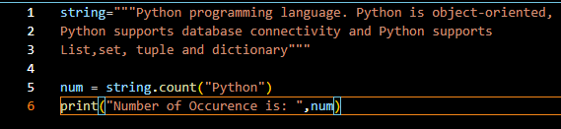



Write a program to count occurrences of all characters within a string

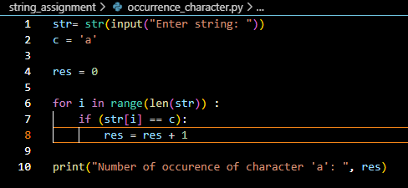



Write a program to reverse a given string

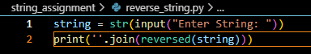



Write a program to accept a string and display the string with changed case.(Change upper case alphabet to lower case and vice versa) (use swapcase())

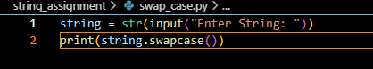



Write a program to count the number of letters in a word.

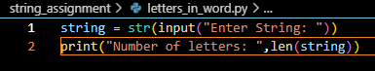



Write a Python program to search a specific word in a string. (use ‘in’operator)

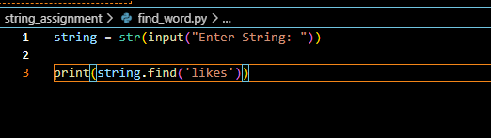



Write a program in Python to count lower, upper, numeric and special characters in a string. (use islower(), isupper(), isnumeric())

